**ADVANCE EXCEL ASSIGNMENT 01**

1. **What do you mean by cells in an excel sheet?**

A cell is the storage unit in Excel. Cells are the boxes in a spreadsheet that may contain data. The cells in a spreadsheet are organized within a column and row in the worksheet, and can be formatted for aesthetics or visibility.

1. **How can you restrict someone from copying a cell from your worksheet?**

On the Review tab, click Protect Sheet. In the Allow all users of this worksheet to list, select the elements you want people to be able to change. Move the pointer to cells for which the Locked box is checked on the Protection tab of the Format Cells dialog box. By default, users are allowed to select locked cells.

1. **How to move or copy the worksheet into another workbook?**

Open the workbook that you want to move the sheet to. On the Window menu, click the workbook that contains the sheet that you want to move. Click the sheet that you want to copy to the other workbook. On the Edit menu, click Sheet > Move or Copy Sheet.

1. **Which key is used as a shortcut for opening a new window document?**

For opening a new window documentpress ctrl+N.

1. 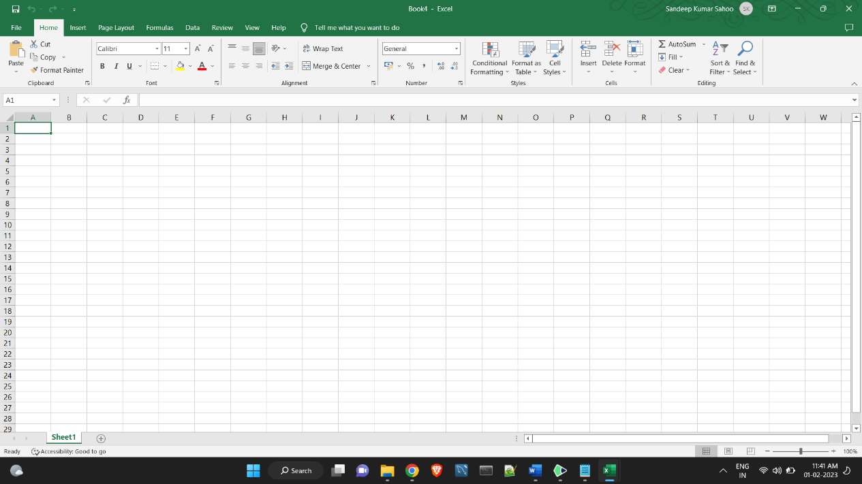**What are the things that we can notice after opening the Excel interface?**

Home

Comprises options like font size, font styles, font colour, background colour, alignment, formatting options and styles, insertion and deletion of cells and editing options

Insert

Comprises options like table format and style, inserting images and figures, adding graphs, charts and sparklines, header and footer option, equation and symbols

Page Layout

Themes, orientation and page setup options are available under the page layout option

Formulas

Since tables with a large amount of data can be created in MS excel, under this feature, you can add formulas to your table and get quicker solutions

Data

Adding external data (from the web), filtering options and data tools are available under this category

Review

Proofreading can be done for an excel sheet (like spell check) in the review category and a reader can add comments in this part

View

Different views in which we want the spreadsheet to be displayed can be edited here. Options to zoom in and out and pane arrangement are available under this category.

1. **When to use a relative cell reference in excel?**

By default, a cell reference is a relative reference, which means that the reference is relative to the location of the cell. If, for example, you refer to cell A2 from cell C2, you are actually referring to a cell that is two columns to the left (C minus A)—in the same row (2).